

**MARMARA UNIVERSITY**

**FACULTY OF ENGINEERING**

CSE3055

Database Systems

Project Step #3

Date: 30.12.2022

|  |  |  |
| --- | --- | --- |
|  | Student Id | Name Surname |
| 1 | 150119745 | Haydar Taha TUNÇ |
| 2 | 150119739 | Emir Ege EREN |
| 3 | 150119743 | Burak DURSUN |

**Project description**

In the project of this database systems course, we are making the database system of a water treatment company named İpek Sutreatment. We are preparing this database in line with the demands of the company. İpek water purification company sells water purification devices and various products. It also provides technical support services.

**Scope**

In this database prepared for the silk water treatment company; Information on products and technical support services provided can be kept. Information about the products can be updated. In addition, the information of customers and employees is also available in the database.

* **Person**: An entity that contains common characteristics of customers and employees.
* **Customer**: Contains the characteristics of people who buy or use the company's products and services.
* **Employee**: It includes the qualifications of the people working and serving in the company.
* **Products**: An entity that contains attributes of products sold or used in the company.
* **Service**: Services offered by the business to customers.
* **SourceFirm**: The company from which the products used or sold are purchased.
* **Sales**: An entity that contains attributes of the product being sold, the buyer, and the sale.
* **License**: An entity that contains the nature of the document showing the authenticity of the product.
* **ServiceRequest**: It is the entity that contains the information that must be kept during the customer's request for service from the company.
* **Stock**: It contains information about how many products are left.
* **ServiceInstallment**: It keeps the installment information of the money to be paid for the service received.
* **SalesInstallment**: It keeps the installment information of the money to be paid for the purchased product.
* **LogTable**: Reports the operation when the data is changed.

**Added Tables:**

* Stock
* SalesInstallment
* ProductInstallment
* LogTable

**Deleted Tables:**

* Bank
* CurrentTable
* PriceList

We added some tables and deleted some tables because the company requested it from us.

**Data and requirements analysis**

* The database must be created in MSSQL.
* The database should store products requested by customers and services requested by customers.
* The database should store the products the company sells and their information.
* The database should hold information of customers and employees.
* Data must be stored uniquely and accurately.

**Diagram of whole database**

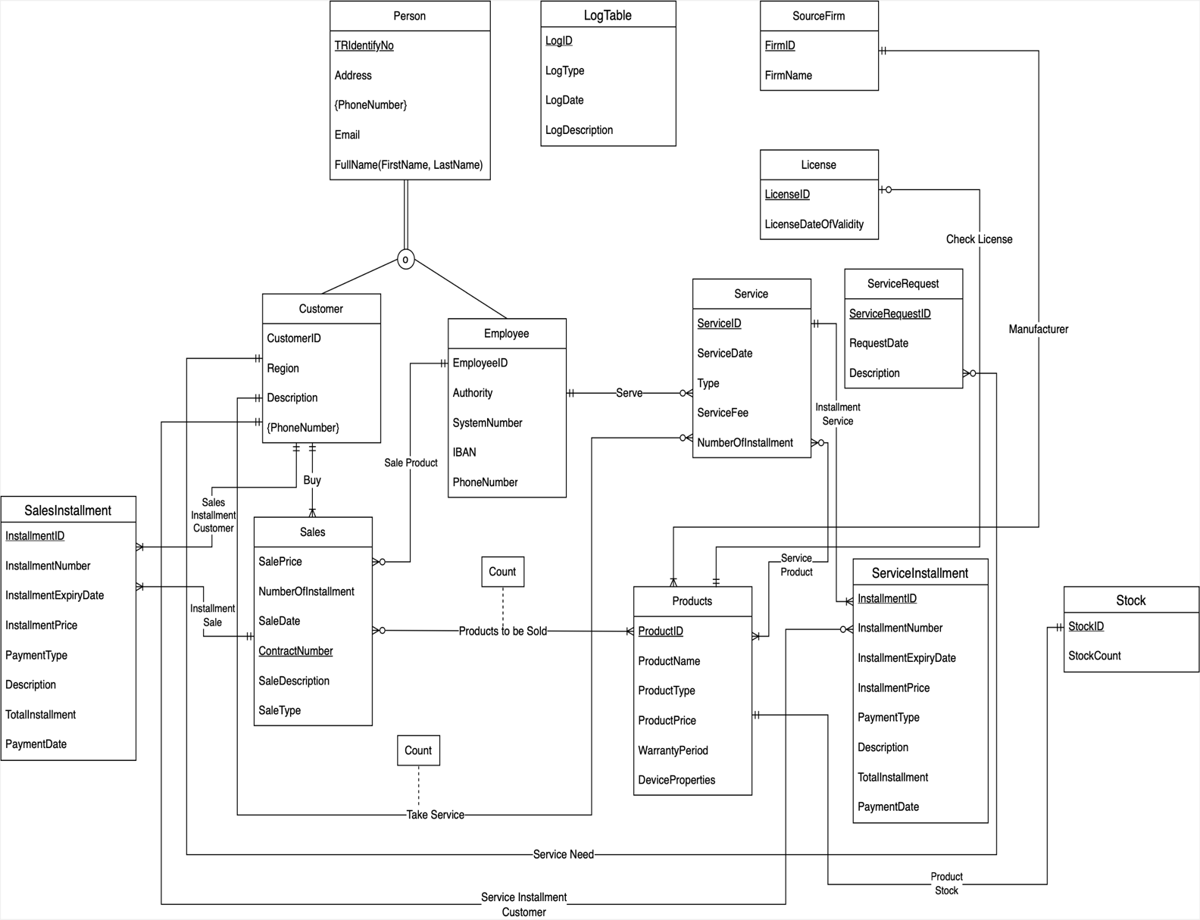

**Tables**

**Person:**

**Name of the fields/columns and Data types of the fields:**

**metin içeren bir resim

Açıklama otomatik olarak oluşturuldu**

**Definition of the table:** An entity that contains common characteristics of customers and employees.

**Information about indexes, primary key, foreign key:**

* Primary Key: TRIdentifyNo

**Information about uniques, identity, check constraints, defaults, computed columns, if any:**

* Unique Keys: TRIdentifyNo,Email
* Constraints: TRIdentifyNo, Address, FirstName, LastName
* Computed Columns: FullName

**Customer:**

**Name of the fields/columns and Data types of the fields:**

**metin içeren bir resim

Açıklama otomatik olarak oluşturuldu**

**Definition of the table:** Contains the characteristics of people who buy or use the company's products and services.

**Information about indexes, primary key, foreign key:**

* Primary Key: CustomerID,TRIdentifyNo

**Information about uniques, identity, check constraints, defaults, computed columns, if any:**

* Unique Keys: CustomerID, TRIdentifyNo
* Constraints: CustomerID, TRIdentifyNo, Region

**Employee:**

**Name of the fields/columns and Data types of the fields:**

**metin içeren bir resim

Açıklama otomatik olarak oluşturuldu**

**Definition of the table:** It includes the qualifications of the people working and serving in the company.

**Information about indexes, primary key, foreign key:**

* Primary Key: EmployeeID, TRIdentifyNo

**Information about uniques, identity, check constraints, defaults, computed columns, if any:**

* Unique Keys: EmployeeID, TRIdentifyNo, IBAN, PhoneNumber
* Constraints: EmployeeID, TRIdentifyNo, Authority, PhoneNumber

**Sales:**

**Name of the fields/columns and Data types of the fields:**

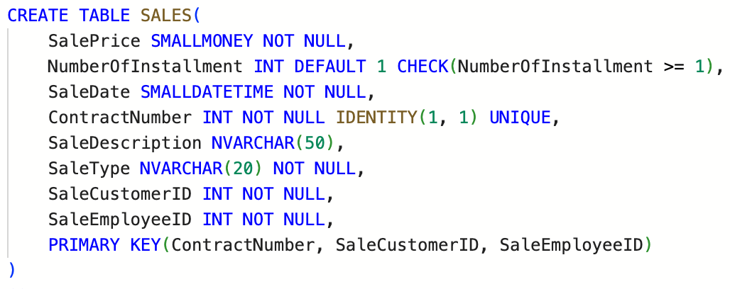

**Definition of the table:** An entity that contains attributes of the product being sold, the buyer, and the sale.

**Information about indexes, primary key, foreign key:**

* Primary Key: ContractNumber, SaleCustomerID, SaleEmployeeID

**Information about uniques, identity, check constraints, defaults, computed columns, if any:**

* Unique Keys: ContractNumber
* Constraints: SalePrice, SaleDate, ContractNumber, SaleType, SaleCustomerID, SaleEmployeeID, NumberOfInstallment
* Defaults: NumberOfInstallment
* Computed Columns: NumberOfInstallment

**Products:**

**Name of the fields/columns and Data types of the fields:**

**metin içeren bir resim

Açıklama otomatik olarak oluşturuldu**

**Definition of the table:** An entity that contains attributes of products sold or used in the company.

**Information about indexes, primary key, foreign key:**

* Primary Key: ProductID

**Information about uniques, identity, check constraints, defaults, computed columns, if any:**

* Unique Keys: ProductID
* Constraints: ProductID, ProductName, ProductType, ProductPrice, WarrantyPeriod, ProductSourceFirmID

**Stock:**

**Name of the fields/columns and Data types of the fields:**

**metin içeren bir resim

Açıklama otomatik olarak oluşturuldu**

**Definition of the table:** It contains information about how many products are left.

**Information about indexes, primary key, foreign key:**

* Primary Key: StockID, StockProductID

**Information about uniques, identity, check constraints, defaults, computed columns, if any:**

* Unique Keys: StockID
* Constraints: StockID, StockCount, StockProductID

**SourceFirm:**

**Name of the fields/columns and Data types of the fields:**

**metin içeren bir resim

Açıklama otomatik olarak oluşturuldu**

**Definition of the table:** The company from which the products used or sold are purchased.

**Information about indexes, primary key, foreign key:**

* Primary Key: FirmID

**Information about uniques, identity, check constraints, defaults, computed columns, if any:**

* Unique Keys: FirmID
* Constraints: FirmID, FirmName

**License:**

**Name of the fields/columns and Data types of the fields:**

**metin içeren bir resim

Açıklama otomatik olarak oluşturuldu**

**Definition of the table:** An entity that contains the nature of the document showing the authenticity of the product.

**Information about indexes, primary key, foreign key:**

* Primary Key: LicenseID, LicenseProductID

**Information about uniques, identity, check constraints, defaults, computed columns, if any:**

* Unique Keys: LicenseID
* Constraints: LicenseID, LicenseDateOfValidity, LicenseProductID

**Service:**

**Name of the fields/columns and Data types of the fields:**

**metin içeren bir resim

Açıklama otomatik olarak oluşturuldu**

**Definition of the table:** Services offered by the business to customers.

**Information about indexes, primary key, foreign key:**

* Primary Key: ServiceID, ServiceCustomerID, ServiceEmployeeID

**Information about uniques, identity, check constraints, defaults, computed columns, if any:**

* Unique Keys: ServiceID
* Constraints: ServiceID, ServiceDate,Type, ServiceFee, NumberOfInstallment, ServiceCustomerID, ServiceEmployeeID
* Defaults: NumberOfInstallment
* Computed Columns: NumberOfInstallment

**ServiceRequest:**

**Name of the fields/columns and Data types of the fields:**

**metin içeren bir resim

Açıklama otomatik olarak oluşturuldu**

**Definition of the table:** It is the entity that contains the information that must be kept during the customer's request for service from the company.

**Information about indexes, primary key, foreign key:**

* Primary Key: ServiceRequestID, ServiceRequestCustomerID

**Information about uniques, identity, check constraints, defaults, computed columns, if any:**

* Unique Keys: ServiceRequestID
* Constraints: ServiceRequestID, RequestDate, ServiceRequestCustomerID

**ServiceInstallment:**

**Name of the fields/columns and Data types of the fields:**

**metin içeren bir resim

Açıklama otomatik olarak oluşturuldu**

**Definition of the table:** It keeps the installment information of the money to be paid for the service received.

**Information about indexes, primary key, foreign key:**

* Primary Key: InstallmentID, InstallmentServiceID, InstallmentCustomerID

**Information about uniques, identity, check constraints, defaults, computed columns, if any:**

* Unique Keys: InstallmentID
* Constraints: InstallmentID, InstallmentNumber, InstallmentExpiryDate, InstallmentPrice, TotalInstallment, PaymentDate, InstallmentServiceID, InstallmentCustomerID
* Defaults: PaymentDate
* Computed Columns: TotalInstallment

**SalesInstallment:**

**Name of the fields/columns and Data types of the fields:**

**metin içeren bir resim

Açıklama otomatik olarak oluşturuldu**

**Definition of the table:** It keeps the installment information of the money to be paid for the purchased product.

**Information about indexes, primary key, foreign key:**

* Primary Key: InstallmentID, InstallmentContract, InstallmentCustomerID

**Information about uniques, identity, check constraints, defaults, computed columns, if any:**

* Unique Keys: InstallmentID
* Constraints: InstallmentID, InstallmentNumber, InstallmentExpiryDate, InstallmentPrice, TotalInstallment, PaymentDate, InstallmentServiceID, InstallmentCustomerID
* Defaults: PaymentDate
* Computed Columns: TotalInstallment

**LogTable:**

**Name of the fields/columns and Data types of the fields:**

**metin içeren bir resim

Açıklama otomatik olarak oluşturuldu**

**Definition of the table:** Reports the operation when the data is changed.

**Information about indexes, primary key, foreign key:**

* Primary Key: LogID

**Information about uniques, identity, check constraints, defaults, computed columns, if any:**

* Unique Keys: LogID
* Constraints: LogID, LogType, LogDate, LogDescription

**Views**

1. **vw_CustomerList**

**Definition:** A view that shows a list of all customers with their full names, phone numbers, and addresses.

**Screenshots of the code of each view and its output:**

**metin içeren bir resim

Açıklama otomatik olarak oluşturuldu**

tablo içeren bir resim

Açıklama otomatik olarak oluşturuldu

1. **vw_DetailedSales:**

**Definition:** This view is a show that lists sales in chronological order. Inside this view, some information about the sale is shown.

**Screenshots of the code of each view and its output:**

**metin içeren bir resim

Açıklama otomatik olarak oluşturuldu**

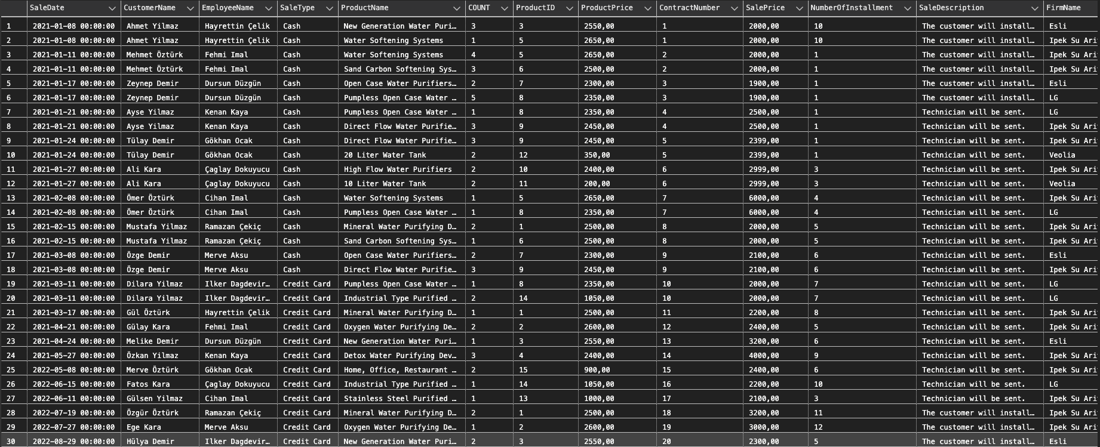

1. **vw_ProductSales:**

**Definition:** Some information about the products sold in 2022 is shown.

**Screenshots of the code of each view and its output:**

**metin içeren bir resim

Açıklama otomatik olarak oluşturuldu**

metin, hesap makinesi içeren bir resim

Açıklama otomatik olarak oluşturuldu

1. **vw_ProductSalesCount:**

**Definition:** This view shows the product name, product type, total quantity sold, and total revenue generated for each product with more than 5 units sold, sorted in descending order by total revenue.

**Screenshots of the code of each view and its output:**

**metin içeren bir resim

Açıklama otomatik olarak oluşturuldu**

metin, skorbord, ekran görüntüsü içeren bir resim

Açıklama otomatik olarak oluşturuldu

1. **vw_SalesSummary:**

**Definition:** This view shows the following information for each sale: contract number, customer name, employee name, product name, number of products, product price, sales price, number of installments, date of sale, type of sale, and profit.

**Screenshots of the code of each view and its output:**

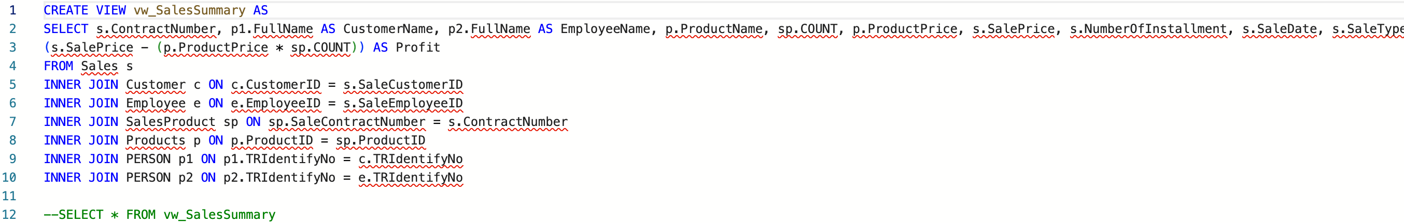

metin, elektronik eşyalar, pencere, bilgisayar içeren bir resim

Açıklama otomatik olarak oluşturuldu

1. **vw_SortedServices:**

**Definition:** It is a view sorted by date of services, customer and employee names, service type and price.

**Screenshots of the code of each view and its output:**

**metin içeren bir resim

Açıklama otomatik olarak oluşturuldu**

metin, skorbord, levha içeren bir resim

Açıklama otomatik olarak oluşturuldu

**Triggers**

1. **tr_InsertSalesInstallment**

**Definition, and when/how it works:**

This trigger takes the total number of installments when data is added to the sales table, then adds data as much as the number of installments to the sales installments table and divides the total amount by the number of installments.

**Screenshot of the code of each trigger:**

**metin içeren bir resim

Açıklama otomatik olarak oluşturuldu**

**Screenshots of after states of the table data that each trigger works on:**

pencere, klima, cihaz içeren bir resim

Açıklama otomatik olarak oluşturuldu

1. **tr_InsertServiceInstallment**

**Definition, and when/how it works:**

This trigger takes the total number of installments when data is added to the service table, then adds data as the number of installments to the service installment table and divides the total amount by the number of installments.

**Screenshot of the code of each trigger:**

**metin içeren bir resim

Açıklama otomatik olarak oluşturuldu**

**Screenshots of after states of the table data that each trigger works on:**

pencere, klima içeren bir resim

Açıklama otomatik olarak oluşturuldu

**Stored procedures**

1. **sp_GetCustomerInformation**

**Definition:** It shows some information about the customer according to the given CustomerID.

**Screenshots of the code of each stored procedure:**

**metin içeren bir resim

Açıklama otomatik olarak oluşturuldu**

**Screenshots of after states of the data that each stored procedure works on:**



1. **sp_GetProductAvailability**

**Definition:** It checks whether the product is in sufficient quantity according to its stock.

**Screenshots of the code of each stored procedure:**

**metin içeren bir resim

Açıklama otomatik olarak oluşturuldu**

**Screenshots of after states of the data that each stored procedure works on:**

tablo içeren bir resim

Açıklama otomatik olarak oluşturuldu

1. **sp_GetTotalSalesByEmployee**

**Definition:** Shows how much money the employee made, how many sales, name and authorization between the given EmployeeID and the given dates.

**Screenshots of the code of each stored procedure:**

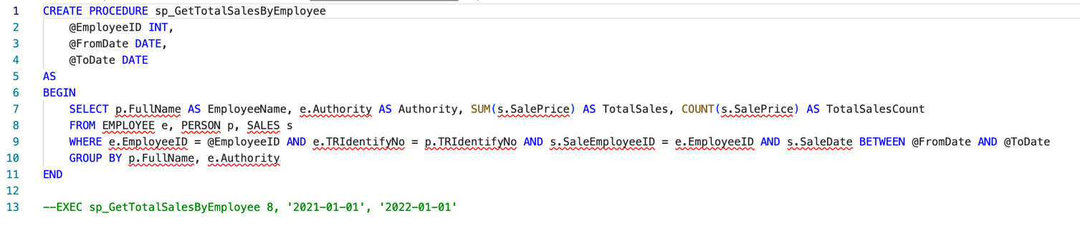

**Screenshots of after states of the data that each stored procedure works on:**



tablo içeren bir resim

Açıklama otomatik olarak oluşturuldu

1. **sp_UpdateStock**

**Definition:** Updates the stock information according to the ProductID given as a parameter.

**Screenshots of the code of each stored procedure:**

**metin içeren bir resim

Açıklama otomatik olarak oluşturuldu**

1. **sp_AddSaleAndSaleProduct**

**Definition:** Adds sales data to the sales table

**Screenshots of the code of each stored procedure:**

**metin içeren bir resim

Açıklama otomatik olarak oluşturuldu**

1. **sp_GetEmployeeTotalEarningsInPeriodForService**

**Definition:** By giving the id and date range of the employee, it shows the earnings of the company from the services and the number of services that he went to between those dates.

**Screenshots of the code of each stored procedure:**

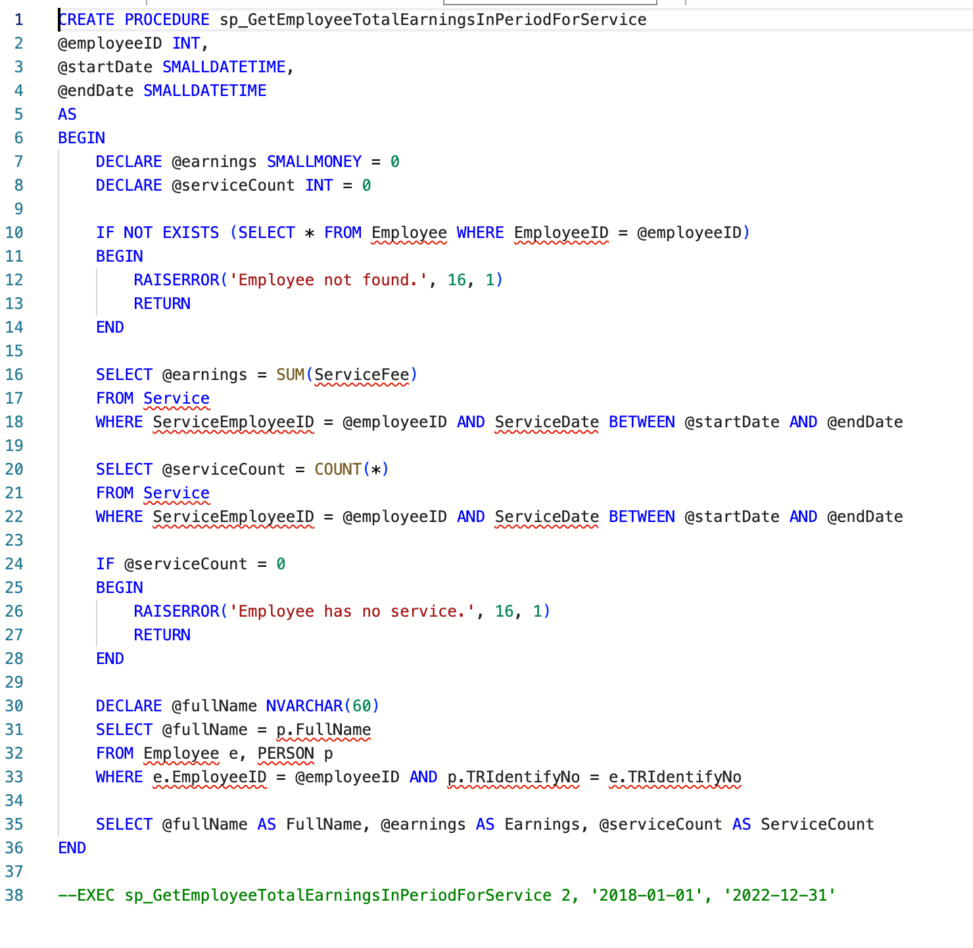

**Screenshots of after states of the data that each stored procedure works on:**

metin içeren bir resim

Açıklama otomatik olarak oluşturuldu

metin içeren bir resim

Açıklama otomatik olarak oluşturuldu

1. **sp_GetCustomerServiceRequestCount**

**Definition:** Shows how many service requests the customer has created between the given date.

**Screenshots of the code of each stored procedure:**

**metin içeren bir resim

Açıklama otomatik olarak oluşturuldu**

**Screenshots of after states of the data that each stored procedure works on:**



1. **sp_GetProductCountBySourceFirm**

**Definition:** Shows how many products SourceFirm has.

**Screenshots of the code of each stored procedure:**

**metin içeren bir resim

Açıklama otomatik olarak oluşturuldu**

**Screenshots of after states of the data that each stored procedure works on:**



tablo içeren bir resim

Açıklama otomatik olarak oluşturuldu